In computers, to mount is to make a group of files in a file system structure accessible to a user or user group. In some usages, it means to **make a device physically accessible**. ...

**Mounting and Unmounting File Systems**

Before you can access the files on a file system, you need to mount the file system. Mounting a file system attaches that file system to a directory (**mount point**) and makes it available to the system. The root (/) file system is always mounted. Any other file system can be connected or disconnected from the root (/) file system.

When you mount a file system, any files or directories in the underlying mount point directory are unavailable as long as the file system is mounted. These files are not permanently affected by the mounting process, and they become available again when the file system is unmounted. However, mount directories are typically empty, because you usually do not want to obscure existing files.

For example, the figure below shows a local file system, starting with a root (/) file system and subdirectories sbin, etc, and opt.

**Figure 34-1 Sample root (/) File System**

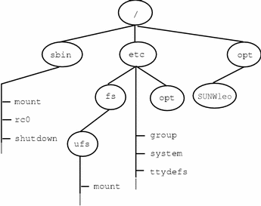

Now, say you wanted to access a local file system from the /opt file system that contains a set of unbundled products.

First, you must create a directory to use as a mount point for the file system you want to mount, for example, /opt/unbundled. Once the mount point is created, you can mount the file system (by using the mount command), which makes all of the files and directories in /opt/unbundled available, as shown in the figure below. See [Chapter 36, Mounting and Unmounting File Systems (Tasks)](https://docs.oracle.com/cd/E19455-01/805-7228/6j6q7uev0/index.html) for detailed instructions on how to perform these tasks.

**Figure 34-2 Mounting a File System**

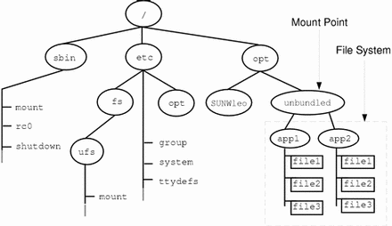

**The Mounted File System Table**

Whenever you mount or unmount a file system, the /etc/mnttab (mount table) file is modified with the list of currently mounted file systems. You can display the contents of this file with the cat or more commands, but you cannot edit it. Here is an example of an /etc/mnttab file:

|  |
| --- |
| $ **more /etc/mnttab**  /dev/dsk/c0t0d0s0 / ufs rw,intr,largefiles,onerror=panic,suid,dev=2200000 938557523  /proc /proc proc dev=3180000 938557522  fd /dev/fd fd rw,suid,dev=3240000 938557524  mnttab /etc/mnttab mntfs dev=3340000 938557526  swap /var/run tmpfs dev=1 938557526  swap /tmp tmpfs dev=2 938557529  /dev/dsk/c0t0d0s7 /export/home ufs rw,intr,largefiles,onerror=panic,suid,dev=2200007 938557529  $ |